Day 18 Assignments : (as I don’t have gcp working, I’ve done it half)

1.Grab IP address of all ssh attackers in a file.

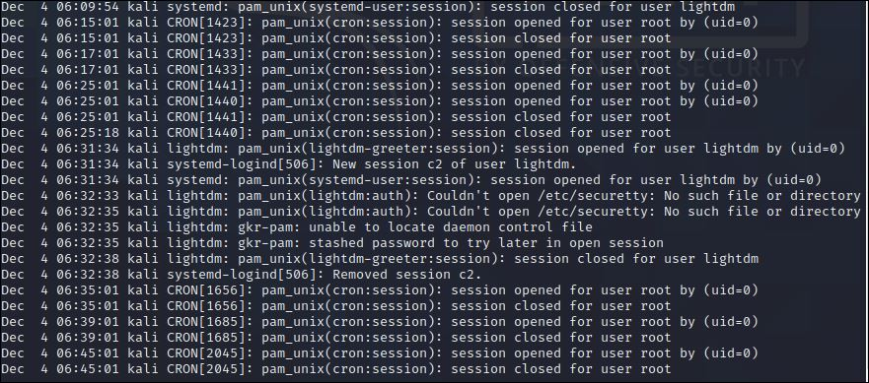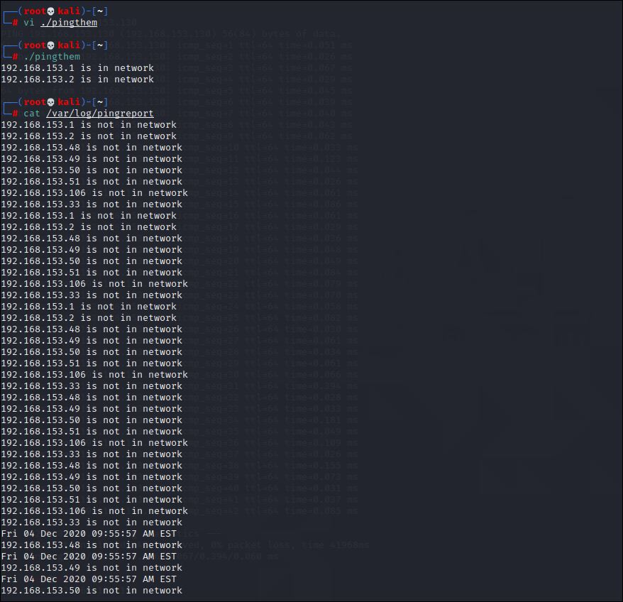

2. Use this file to append entries to /etc/hosts.deny.

3. Expose the content of hosts.deny in a web page.

